A Bayesian approach to understanding artificial enzymatic networks

Mathieu G. Baltussen

Jeroen van de Wiel

Cristina Lía Fernández Regueiro

Miglé Jakštaitė

Wilhelm T.S. Huck

# Summary/Abstract

In order to create artificial enzymatic networks capable of increasingly complex behaviour, an improved methodology in understanding and controlling the kinetics of these networks is needed. Here, we introduce a Bayesian analysis approach which allows for the accurate inference of enzyme kinetic parameters and determination of most likely reaction mechanisms, by combining data from different experiments and network topologies in a single probabilistic analysis framework. This Bayesian approach explicitly allows us to continuously improve our parameter estimates and behaviour predictions by iteratively adding new data to our models, while automatically taking into account uncertainties introduced by the experimental setups or the chemical processes in general. We demonstrate the potential of this approach by characterizing systems of enzymes compartmentalized in beads inside flow reactors. The approach we introduce here could be relevant to the design of artificial enzymatic networks, making the design of such networks more efficient, and robust against the accumulation of experimental errors.

# Introduction

Enzymatic reaction networks (ERN’s) are ubiquitous in life, and are responsible for many key cellular processes, such as energy metabolism, signalling pathways, and cell division1–3. The fields of synthetic biology and systems chemistry are concerned with understanding and reproducing the behaviour of complex (bio)chemical systems such as these ERNs in artificial systems4–7. An important aspect of this is estimating the mechanisms and kinetics of the enzymatic activity in these systems8,9. But while the development of artificial ERNs with more complex behaviour continuous10,11, methods are missing to not only obtain realistic kinetic parameter estimates, but to simultaneously allow for the evaluation of the relevance and correctness of existing kinetic models.

This lack of accurate and experimentally realistic parameter and mechanism estimation, that can reliably predict the relevant experimental regimes in which a desired functional output will be observed, greatly limits the efficient exploration of more complex systems. Furthermore, while the fitting of a model to experimental data is in principle relatively simple, in practice numerous sources of uncertainty are encountered, including experimental errors and unknown inhibitory or allosteric effects. Typically, the kinetic parameters of an enzymatic reaction are estimated from a single dataset, using least-squares regression or similar maximum likelihood estimation methods. Although this approach is well-established, there are multiple downsides12. First, any sources of uncertainty must be explicitly modelled in, which would require an exact knowledge of the influence of these uncertainties on the final experimental results13,14. Secondly, this approach often neglects additional sources of data, either from previous or additional experiments, or from literature. And lastly, estimation of enzyme kinetics is often done using rather limited datasets, which should increase the uncertainty of the obtained parameter values, but in practice can potentially lead to overfitting of the proposed model and numerous other biases15,16.

To improve the kinetic analysis of enzymatic activity, an analysis framework capable of quantifying these sources of epistemic uncertainty and using all available data, while remaining intuitive and accessible, is required. We demonstrate such a framework based on Bayesian methods for the inference of kinetic parameters and comparison of reaction mechanisms of immobilized enzymes in a flow reactor. This approach is probabilistic in nature, so that any knowledge of kinetic parameters or reaction mechanisms obtained from experimental data is expressed in terms of probability-distributions, instead of specific values. Bayesian methods allow for the explicit incorporation of any information previously obtained on the system in question through the prior, either from literature or previous experiments, resulting in a coherent framework for combining data from different sources17. Additionally, they are ideally suited for estimations under uncertainty and a lack of data18, which is especially relevant for the experimental reality of ERNs, where a lot of variability exists between experiments.

Bayesian methods have been more widely implemented in recent years, mainly due to an increase in available computational power and an increase in general availability of powerful, yet accessible, algorithms. They are used in a wide range of fields, from applications in pure physics19, medicine20, and sociology21, to large-scale metabolomics in systems biology22 and optimized peak detection in chromatographic methods23.

Previous research on the applications of Bayesian methods in enzymatic networks have mostly been attempted from a systems biology perspective, focusing on whole-cell metabolomics22,24,25, or focusing on simulated datasets and evaluating the feasibility of an alternative enzyme rate equation26. The approach introduced here instead focusses on experimental relevance, specifically for the construction of encapsulated enzymes in flow, but is readily adoptable in most experimental enzymatic reactions setups, without requiring extensive computational expertise to employ.

# Methods

## Bead production

TODO: Add bead-production protocol

## Flow experiments

TODO: Add flow experiments protocol

## Modelling of enzyme kinetics in flow

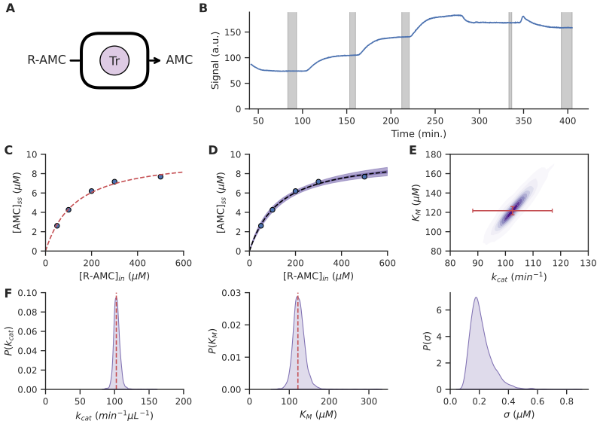

Figure 1: **Inference of kinetics in a flow setup** **A,** Reactors are used to create enzymatic networks with compartmentalized beads and substrates that can flow in and out. **B,** Reactor output of R-AMC cleavage by Trypsin, measuring the fluorescent signal of the product AMC. Substrate input concentration is changed multiple times, and measurements are taken at steady-state (indicated in gray). **C,** Steady-state output concentrations plotted against substrate input concentration. A least-squares fit (red dashed line) is obtained from a flow-modified Michaelis-Menten equation, resulting in parameter estimates $k_{cat}=102.6±4.3$ and $K_{M}=121.7±14.4$. **D,** Bayesian fit of the steady-state output concentrations, including mean posterior predictions (black dashed line) and 95% confidence interval (light purple). **E,** Parameter correlations (purple) automatically obtained from the posterior sampling distributions, and corresponding least-squares estimates and error bars (red) without correlation. **F,** Bayesian probability-distributions of the kinetic parameters $k_{cat}$, $K_{M}$ with corresponding least-squares estimates (red dashed lines), and noise estimate $σ$.

TODO: Update section to connect better to previous experimental sections

All experiments are performed in a microfluidic setup, with the relevant enzymes encapsulated in beads and compartmentalized in a Continuously Stirred Tank Reactor (CSTR), while relevant substrates, inhibitors, and buffer are flown in via syringes attached to a pump setup, as shown in figure 1A-B and described in more detail inref 27. We generally assume that the enzymatic reactions behave according to a Michaelis-Menten-like mechanism, although other mechanisms might also be considered, and add flow-dependent terms to model the dynamics of the flow reactor. Inclusion of these flow-terms yields the following system of Ordinary Differential Equations (ODEs) for a single-substrate single-product reaction:

$$f\left(C,ϕ,θ\right):\left\{\begin{matrix}\frac{d\left[P\right]}{dt} & =\frac{V_{max}\left[S\right]}{K_{M}+\left[S\right]}−k_{f}\left[P\right] \\ \frac{d\left[S\right]}{dt} & =\frac{−V_{max}\left[S\right]}{K_{M}+\left[S\right]}+k_{f}\left({\left[S\right]}_{in}−\left[S\right]\right)\end{matrix}\right.$$

Where $V_{max}=k_{cat}\left[E\right]$ and $K_{M}$ are the kinetic parameters $ϕ$ that generally need to be estimated, and where we introduce a set of control parameters $θ$, in the form of ${\left[S\right]}_{in}$, the effective substrate concentration flown into the reactor, and $k_{f}=\frac{flowrate \left(\frac{μL}{min}\right)}{reactor volume\left(μL\right)}$ the flow-constant. Measurements of the product-concentration are performed when the system has reached steady-state conditions ($\frac{dC}{dt}=0$). A typical example of this is shown in figure 1B for the cleavage of Cbz-Arg-7-amino-4-methylcoumarin (R-AMC) by Trypsin PEBs, for different substrate input concentrations. Usually, kinetic parameter estimates for these types of systems are obtained via a standard linear-regression approach, performing for example a least-squares fit (figure 1C), resulting in a specific set of values and error estimates.

## Creation of Bayesian models

In a Bayesian approach, the probability distributions for parameters of interest are obtained by application of Bayes’ theorem

$$P\left(ϕ | y\right)∝P\left(ϕ\right)P\left(y | ϕ\right)$$

which relates the posterior probability $P\left(ϕ | y\right)$ of a specific parameter value $ϕ$ given the data $y$ observed during an experiment, to the likelihood $P\left(y | ϕ\right)$ of observing that specific data given the parameter value, and any previously available information of the parameter, the prior $P\left(ϕ\right)$.

In the case of a single-substrate, steady-state enzymatic network, the observed data $y$ is given simply by the set of observed steady-state concentrations ${\left[P\right]}_{ss}$ at specific experimental conditions ${\left[S\right]}_{in}$ and $k_{f}$, while the parameter $ϕ$ can be any of the kinetic parameters that is unknown, such as $k_{cat}$ or $K_{M}$. Furthermore, because the data we collect is inherently noisy, we assume that the concentrations we observe are part of a normal distribution ${\left[P\right]}_{obs}∼N\left({\left[P\right]}_{ss},σ\right)$ with a mean equal to the true steady-state concentration and an unknown standard-deviation $σ$. This assumption allows us to write down the form of the likelihood:

$$P\left(y | ϕ\right)=L\left(y,ϕ\right)=N\left({\left[P\right]}_{ss}−{\left[P\right]}_{obs},σ\right)$$

where ${\left[P\right]}_{ss}=g\left(ϕ,θ\right)$ is a function of the kinetic parameters and the experimental conditions. The likelihood incorporates most sources of noise, such as the intrinsic fluctuations of product concentration at steady-state and noise from the used measurement technique, inside the noise-term $σ$. This parameter is then inferred simultaneously with the kinetic parameters $k_{cat}$ and $K_{M}$, allowing us to directly estimate the noise in our observations as well. Any other sources of uncertainty, such as inconclusive data, or a wrong assumed reaction-mechanism, are implicitly encoded into the posterior probability distributions of the kinetic parameters.

We use the Python package PyMC328 and custom-written likelihood functions for observed steady-state concentrations, from which we can sample with the No-U-Turn Sampler (NUTS29) by inclusion of likelihood gradients. The steady-states can be obtained either by symbolically solving $\text{f}\left(\text{C},ϕ,θ\right)=0$, or by numerical root-finding of the vector-function $\text{f}$. The gradients for the numerical steady-states are obtained from the Implicit Function Theorem, which relates the sensitivity of the steady-state concentrations $\frac{∂g}{∂ϕ}$ to the kinetic parameters without needing to explicitly write down an expression for the steady-state concentrations, via $\frac{∂g}{∂ϕ}\left(ϕ,θ\right)=−[\frac{∂f}{∂C}\left(\text{C},ϕ,θ\right)]^{−1}[\frac{∂f}{∂ϕ}\left(\text{C},ϕ,θ\right)]$, while gradients for symbolic steady-states are automatically obtained via automatic differentiation in PyMC3. Using the NUTS-algorithm, we can obtain correlated probability distributions for the value of every kinetic parameter of interest. An example of the resulting fit and parameter estimates for a simple, one-substrate enzyme system are shown in figure 1D-F. Implementations of the models used in this paper and the script to generate the figures can be found in the Supporting Information. TODO: Add reference to SI/notebooks/Github at the end.

# Results and Discussion

## Obtaining improved accuracy from correlated parameter estimates

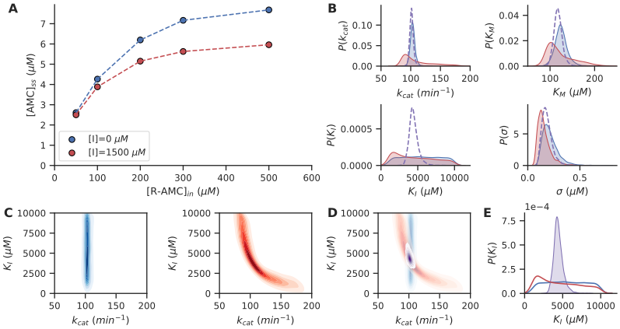

Figure 2: **Improving parameter estimates by exploiting correlations** **A,** Steady-state concentrations of R-AMC cleavage by Trypsin, with and without inhibitor (AAA-AMC). **B,** Posterior parameter estimates obtained from the data without inhibitor present (blue) and with inhibitor present (red). Combining both datasets in one model yields more precise posterior estimates (dashed, purple) **C,** Posterior correlation plots of $k_{cat}$ and $K_{I}$ from the data without inhibitor present (blue, left), showing no correlation, and with inhibitor present (red, right), showing high nonlinear correlation. **D,** Combining data from both experiments yields a new posterior distribution (purple) that exactly corresponds to the intersection from the two experiments separately. **E,** Comparison of posterior $K_{I}$ estimates from the individual datasets (blue, red) to the estimate obtained from the combined dataset (purple).

We first show the relevancy of our Bayesian approach by estimating the kinetic parameters of Trypsin PEBs cleaving a substrate (R-AMC) while in the presence of an inhibitor (Suc-Ala-Ala-Ala-7-amino-4-methylcoumarin, AAA-AMC), shown in figure 2. Two experiments were performed, one where the inhibitor was absent and one where the inhibitor was present (figure 2A). Both of these experiments on their own did not yield enough information to obtain conclusive estimates of all kinetic parameters involved ($k_{cat}$, $K_{M}$, $K_{I}$), as shown in figure 2B. Clearly, from the experiment without inhibitor relatively precise estimates can be obtained on $k_{cat}$ and $K_{M}$, but no information is obtained on the value of the inhibition constant $K_{I}$. Thus, our posterior estimate of the inhibition constant is equivalent to our prior estimate (a uniform distribution between $1$ and $10*{10}^{3}$ $μM$). In contrast, from the experiment with inhibitor present, a posterior estimate for the inhibition constant can be obtained, albeit not a precise one. Additionally, from this experiment alone, the posterior estimates for the other kinetic parameters are also uncertain.

However, while the posterior estimates of the individual parameters remain uncertain, we do obtain additional information by analyzing the posterior correlations, shown in figure 2C. While the experiment without inhibitor does not show any correlation between the value of the estimated $k_{cat}$ and $K_{I}$ values, the experiment with inhibitor present shows a nonlinear correlation between low estimated values of $k_{cat}$ and high values of $K_{I}$, and vice versa.

Combining data from both experiments in a single likelihood function allows us to combine the certainty of the parameter estimates present in the first experiment with the highly-correlated parameter estimates of the second experiment, to obtain a posterior distribution that is essentially an intersection of those obtained from the individual experiments (figure 2D). As expected, this allows us to obtain a much more precise estimate of the inhibitor constant, as shown in figure 2E. Moreover, this procedure yields improved estimates for every parameter in the system, not just the inhibition constant, which can be observed in figure 2B.

Consequently, the Bayesian approach greatly simplifies the iterative addition of experimental data to update parameter estimates. As shown here, subsequent measurements of enzyme activity in the presence of an inhibitor will not only allow an estimation of the inhibition constant, but also retro-actively improves the estimates for the Michaelis constant $K_{M}$ and the turnover number $k_{cat}$.

## Combining diverse experimental datasets

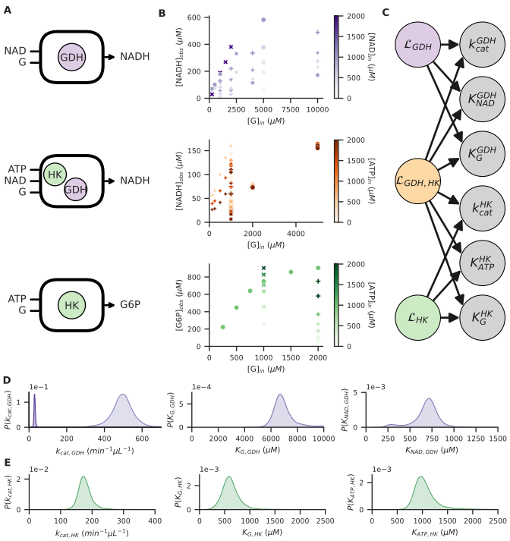

Figure 3: **Combining diverse experimental datasets** **A,** Three different ERN topologies are used in different reactors, and at different experimental conditions (varying input concentrations and volume of PEBs). **B,** Plots showing all collected observations at different input concentrations of glucose (x-axis) and co-factor (color intensity). The observed species is topology-dependent. **C,** Schematic of the causal network relating the observation likelihoods $L_{x}$ to the inferable parameters, where likelihoods corresponding to either the GDH or HK topology only relate to a subset of the parameters. The combined GDH,HK likelihood relates to every kinetic parameter in the probabilistic model. **D,E** Posterior parameter estimates obtained from the model combining all three (GDH, HK, GDH+HK) observation likelihoods. For the GDH $k_{cat}$, two estimates are obtained because PEBs with two different enzyme concentrations were used in different experiments.

More complex ERNs introduce a number of additional challenges in modelling the system’s behaviour. One of these challenges is combining data from a diverse range of experiments, both with variations in experimental conditions, and variations in network topologies due to the enzymes that are present. Additionally, for some experiments only partial data can be obtained, for example in the case where only substrates involved in a single reaction can be observed, while substrates from a different reaction remain undetected.

In figure 3, we show how data obtained from these different types of experiments can be captured in a single probabilistic model. In figure 3A, we distinguish between 3 different network topologies, two with only a single type of enzyme PEB present, either glucose-dehydrogenase (GDH) or hexokinase (HK), and one where both enzymes PEBs are present simultaneously. For all three topologies, multiple experiments are performed at different conditions, such as different substrate input-concentrations and PEB volumes used. For the two single-enzyme topologies, detection of a single substrate is enough for full observability of the network (through stoichiometric conservation), while for the combined HK&GDH topology, only NADH is observed. Thus, the substrates involved in the hexokinase-reaction are not directly detected. These observations are shown in figure 3B.

All three topologies have a corresponding likelihood function that relates the observations to the kinetic parameters in question, as shown schematically in figure 3C (see the SI for the programmmatic implementation of these likelihoods). While the GDH+HK system does not allow for full observability of the network, its likelihood does allow us to correlate the GDH and HK kinetic parameters, consequently leading to improved estimates of all parameters involved.

The resulting posterior estimates of combining all available data are shown in figure 3D, alongside with noise estimates per experiment in figure 3E. For the GDH PEB’s, two different batches were used with different enzyme concentration, resulting in two distinct effective $k_{cat}$ parameters. Estimation of their respective values are performed under the assumption that the $K_{M}$ for the two substrates remain the same for both batches. By directly encoding this assumption into the combined likelihood functions, observations on both batches become relevant for estimation of all the parameters involved.

Correlating the parameter estimates of the individual enzymes through a joint likelihood function allows us to potentially improve parameter estimates by observing a system not directly related to those parameters. Thus, as more and more observations are made, any parameter estimates will increase in accuracy simply by the inclusion of more data. TODO: Update figure to include iterative data-updating

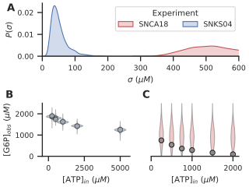

Figure 4: **Evaluating noise estimates** **A,** Posterior experimental uncertainty estimates for two specific HK-experiments, obtained from the posterior distributions calculated from the full dataset of all experiments. One experiment (blue) has a low estimated uncertainty, while the other experiment (red) has a much higher estimated uncertainty. **B,**  Associated observed datapoints of the low-uncertainty experiment, and the posterior predictive distribution of expected observations. **C,**  Associated observation datapoints of the high-uncertainty experiment, and the posterior predictive distributions of the expected observations.

TODO: Improve figure quality (colors, plot sizes, etc…)

Additionally, by estimating the noise or uncertainty in every experiment individually, it becomes more practical for a large number of experiments to determine which ones have corresponding results, and which ones are potential outliers or contain experimental errors. This can be observed especially in the noise estimates for two specific HK experiments, as shown in figure 4 One experiment, with experiment SNKS04, has a relatively low noise estimates (figure 4A) and correspondingly, the posterior predictions obtained from the model are similar to the actual observations (figure 4B). However, another experiment stands out with a much higher noise estimate ($σ∼400−600 μM$), which indicates some unknown fundamental error in the observations made during that experiment. Consequently, the posterior predictions show an extreme spread and do not correlate well with the actual observations (figure 4C). Importantly, these noise estimates are obtained by conditioning of the individual observations on the complete dataset of all experiments. Large noise estimates therefore imply results that do not correspond with most other performed experiments.

By estimating the noise parameters alongside all of the kinetic parameters, individual experiments are allowed to be ‘wrong’, and consequently influence the final parameter estimates less then other experiments. While not a solution for badly performed experiments, it does protect against drawing incorrect conclusions from incorrect data. Consequently, the noise estimates indirectly act as an automatic weighting factor for individual experiments, where experiments with higher estimated noise are less relevant towards the kinetic parameter estimations. It can also function as a key indicator for experiments influenced by an unknown source of error or systematic bias, especially in cases where large datasets collected over longer timeperiods are involved.

## Comparing reaction mechanism hypotheses

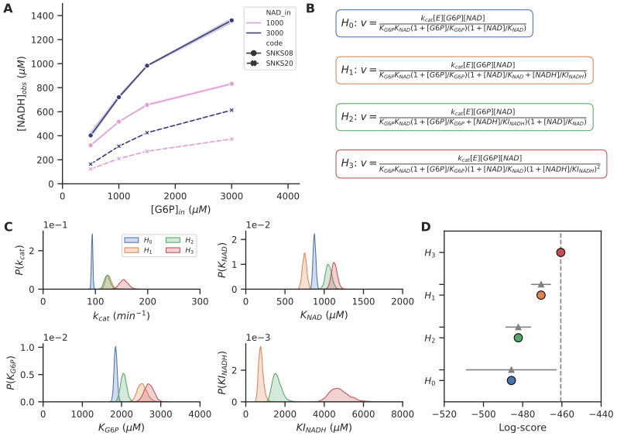

Figure 5: **Comparing reaction mechanism hypotheses** **A,** Steady-state concentrations obtained during two experiments, from a G6PDH system at different glucose-6-phosphate input concentrations and NAD input concentrations. **B,** Four different hypotheses for Michaelis-Menten mechanisms without ($H_{0}$), and with NADH product inhibition ($H_{1}$- $H_{3}$). Only the reaction-rate is shown, but full sets of ODE’s with additional flow-terms are used in the probabilistic model. **C,** Posterior parameter estimates for all four hypotheses. $H_{0}$ does not include an inhibition constant $KI_{NADH}$, but all other hypotheses do. **D,** Comparison of the PSIS-LOO information criterion for all four hypotheses (colored), and standard errors of the difference in information criterion with respect to the top-ranked model (grey).

TODO: Update figure and text with latest data when available

The microscopic mechanisms underlying enzymatic reactions often allow for the creation of more complex kinetic models than simple Michaelis-Menten kinetics. However, a more complex model, with more kinetic parameters, does not necessarily imply a more useful model. Instead, in the presence of uncertain data, it can lead to overfitting and unrealistically high certainty in the estimates.

In figure 5 we show how the posterior estimates obtained using our Bayesian approach, can be used to compare different hypotheses for the reaction mechanism and associated kinetics of glucose-6-phosphate dehydrogenase (G6PDH) PEBs. From a set of experiments performed at varying experimental conditions (figure 5A), we propose a number of different hypotheses describing the suspected mechanism of product inhibition by NADH on the reaction rate (figure 5B). We also include a 0-hypothesis describing a mechanism where the formation of NADH has no inhibiting effect, although the inclusion of a 0-hypothesis is not necessary for using this methodology.

We consider 3 modes of NADH inhibition: competitive inhibition of the NAD-binding site ($H_{1}$), competitive inhibition of the G6P-binding site ($H_{2}$), and cooperative non-competitive inhibition of the enzyme activity ($H_{3}$). All four hypotheses result in posterior distributions that give well-defined parameter estimates (figure 5C), from which it is difficult to conclude the most likely hypothesis. Instead, because the experimental noise per experiment is estimated alongside the kinetic parameters, the zero-hypothesis yields unrealistically precise estimates, due to to the algorithm indicating that under the assumption that this hypothesis is true, one of the experiments included has to contain very large errors (see SI). The three hypotheses that do model the influence product-inhibition have similar precisions in their parameter estimates.

To compare all hypotheses, and determine the most (and least) likely ones, we perform a Pareto Smoothed Importance Sampling Leave-one-out (PSIS-LOO) cross-validation directly from the posterior probability distributions30. This test efficiently determines the model that approximates the observed data best, while taking into consideration the complexity of the models (e.g. the number of kinetic parameters involved) to prevent overfitting. From this hypothesis comparison we can conclude that given the experiments performed up to this point, a cooperative non-competitive inhibition is the most likely product-inhibition mechanism occuring in the G6PDH PEBs, although the other reaction mechanisms cannot yet be assumed out-of-question. Similarly, while the zero-hypothesis is likely not correct, a small chance exists that indeed one experiment does contain large experimental errors and is therefore unreliable.

Comparing reaction mechanisms from a probabilistic perspective is a potentially powerful tool that can be used to make informed decisions about the next best experiments to perform when a lot of different mechanisms are under consideration. Importantly, it can equally be used in re-analyzing old datasets in light of newly discovered or proposed mechanisms, or when new data becomes available. However, care should be taken in interpreting the results from these comparisons as final conclusions. Tt is not a suitable method to make statements about the absolute truth of a hypothesis, as the test only check the predictive power of each hypothesis relative to all other hypotheses under consideration. Therfore, if no correct reaction mechanism is included in the hypotheses, then it will also not be considered in the test.

# Conclusion & Outlook

We have demonstrated how a Bayesian approach towards analyzing enzymatic reaction networks allows for more accurate inference of the kinetics in these networks, while simultaneously taking into account any experimental or model-related uncertainties. Using this approach, we have shown how experimental data can be combined in one coherent framework, in order for us to correlate the findings in these experiments and improve the estimation of parameters, as well as outlier detection. This approach essentially allows us to continuously improve these estimates further by iteratively adding more experimental data to our models. Moreover, this means that any new experiment might have the potential to unlock more information from older experiments in the process, enabling much more efficient data gathering. Lastly, we have shown how this approach can be used to compare the likelihood of different reaction mechanism hypothesis.

Bayesian methods open up multiple new areas of possibilities for the design of more complex enzymatic reaction networks, and for systems chemistry in general. In addition to the findings presented here, a lot of potential exists in the usage of knowledge from literature for more realistic prior distributions, which could improve the obtained estimates further, and could allow for direct comparison between new results and previous studies. Furthermore, more advanced hierarchical models and the inclusion of latent variables could potentially aid in discovering previously unknown interactions or hidden factors affecting the behaviour of ERNs31, both from a chemical point-of-view (allosteric effects, influence of pH) and an experimental point-of-view (systematic measurement errors, equipment deterioration). Finally, calculation of the full posterior probability distributions opens the door for determining optimal experimental designs32,33. These designs could be aimed at a variety of different goals, such as experimental conditions for the maximum information gain for a certain kinetic parameter, but also the maximum production of a specific substrate or set of substrates, taking automatically into account any uncertainties that still exist about the behaviour of these systems.

We do note that the methods introduced here are still computationally relatively expensive, and some of the sampling techniques are not yet suitable for every type of data. Additionally, while our approach can indicate the presence of bad data and experimental errors, it does not guarantee the absence of sources of error. Care should still be taken to avoid a false sense of security when precise parameter estimates are obtained.

In conclusion, we have shown that the Bayesian approach we demonstrate here is highly relevant for the construction of complex enzymatic networks, allowing researchers to increase the predictability and reproducibility of artificial enzymatic networks, and allowing the field of enzymatic reaction networks to mature beyond toy models and proof-of-concepts.

# Associated Content

**Supporting Information** TODO: add description of supporting information and link to Github

# Author Information

TODO: Add all author information **Corresponding Author** **Author Contributions**

# Acknowledgments

# References

(1) Barabási, A.-L.; Oltvai, Z. N. Network biology: understanding the cell’s functional organization. *Nature Reviews Genetics* **2004**, *5* (2), 101–113. https://doi.org/[10.1038/nrg1272](https://doi.org/10.1038/nrg1272).

(2) Kholodenko, B. N. Cell-signalling dynamics in time and space. *Nature Reviews Molecular Cell Biology* **2006**, *7* (3), 165–176. https://doi.org/[10.1038/nrm1838](https://doi.org/10.1038/nrm1838).

(3) Boccaletti, S.; LATORA, V.; MORENO, Y.; CHAVEZ, M.; HWANG, D. U. Complex networks: Structure and dynamics. *Physics Reports* **2006**, *424* (4-5), 175–308. https://doi.org/[10.1016/j.physrep.2005.10.009](https://doi.org/10.1016/j.physrep.2005.10.009).

(4) Purnick, P. E. M.; Weiss, R. The second wave of synthetic biology: From modules to systems. *Nature Reviews Molecular Cell Biology* **2009**, *10* (6), 410–422. https://doi.org/[10.1038/nrm2698](https://doi.org/10.1038/nrm2698).

(5) Novák, B.; Tyson, J. J. Design principles of biochemical oscillators. *Nature Reviews Molecular Cell Biology* **2008**, *9* (12), 981–991. https://doi.org/[10.1038/nrm2530](https://doi.org/10.1038/nrm2530).

(6) Ludlow, R. F.; Otto, S. Systems chemistry. *Chem. Soc. Rev.* **2008**, *37* (1), 101–108. https://doi.org/[10.1039/B611921M](https://doi.org/10.1039/B611921M).

(7) Ashkenasy, G.; Hermans, T. M.; Otto, S.; Taylor, A. F. Systems chemistry. *Chemical Society Reviews* **2017**, *46* (9), 2543–2554. https://doi.org/[10.1039/C7CS00117G](https://doi.org/10.1039/C7CS00117G).

(8) Roekel, H. W. H. van; Rosier, B. J. H. M.; Meijer, L. H. H.; Hilbers, P. A. J.; Markvoort, A. J.; Huck, W. T. S.; Greef, T. F. A. de. Programmable chemical reaction networks: emulating regulatory functions in living cells using a bottom-up approach. *Chemical Society Reviews* **2015**, *44* (21), 7465–7483. https://doi.org/[10.1039/C5CS00361J](https://doi.org/10.1039/C5CS00361J).

(9) Wong, A. S. Y. Y.; Huck, W. T. S. S. Grip on complexity in chemical reaction networks. *Beilstein Journal of Organic Chemistry* **2017**, *13*, 1486–1497. https://doi.org/[10.3762/bjoc.13.147](https://doi.org/10.3762/bjoc.13.147).

(10) Semenov, S. N.; Wong, A. S. Y.; Van Der Made, R. M.; Postma, S. G. J.; Groen, J.; Van Roekel, H. W. H.; De Greef, T. F. A.; Huck, W. T. S. Rational design of functional and tunable oscillating enzymatic networks. *Nature Chemistry* **2015**, *7* (2), 160–165. https://doi.org/[10.1038/nchem.2142](https://doi.org/10.1038/nchem.2142).

(11) Maguire, O. R.; Wong, A. S. Y.; Baltussen, M. G.; Duppen, P.; Pogodaev, A. A.; Huck, W. T. S. Dynamic Environments as a Tool to Preserve Desired Output in a Chemical Reaction Network. *Chemistry – A European Journal* **2020**, *26* (7), 1676–1682. https://doi.org/[10.1002/chem.201904725](https://doi.org/10.1002/chem.201904725).

(12) Efron, B.; Hastie, T. *Computer Age Statistical Inference*; Cambridge University Pr., 2016; p 496.

(13) Gábor, A.; Villaverde, A. F.; Banga, J. R. Parameter identifiability analysis and visualization in large-scale kinetic models of biosystems. *BMC Systems Biology* **2017**, *11* (1), 54. https://doi.org/[10.1186/s12918-017-0428-y](https://doi.org/10.1186/s12918-017-0428-y).

(14) Lillacci, G.; Khammash, M. Parameter Estimation and Model Selection in Computational Biology. *PLoS Comput Biol* **2010**, *6* (3), 1000696. https://doi.org/[10.1371/journal.pcbi.1000696](https://doi.org/10.1371/journal.pcbi.1000696).

(15) Wainer, H. The Most Dangerous Equation. *American Scientist* **2007**, *95* (3), 249. https://doi.org/[10.1511/2007.65.249](https://doi.org/10.1511/2007.65.249).

(16) Silver, N. *The Signal and the Noise: Why so many predictions fail, but some don’t*; Penguin Group, 2021; p 534.

(17) Schoot, R. van de; Depaoli, S.; King, R.; Kramer, B.; Märtens, K.; Tadesse, M. G.; Vannucci, M.; Gelman, A.; Veen, D.; Willemsen, J.; Yau, C. Bayesian statistics and modelling. *Nature Reviews Methods Primers* **2021**, *1* (1), 1. https://doi.org/[10.1038/s43586-020-00001-2](https://doi.org/10.1038/s43586-020-00001-2).

(18) McNeish, D. On Using Bayesian Methods to Address Small Sample Problems. *Structural Equation Modeling: A Multidisciplinary Journal* **2016**, *23* (5), 750–773. https://doi.org/[10.1080/10705511.2016.1186549](https://doi.org/10.1080/10705511.2016.1186549).

(19) Toussaint, U. von. Bayesian inference in physics. *Reviews of Modern Physics* **2011**, *83* (3), 943–999. https://doi.org/[10.1103/RevModPhys.83.943](https://doi.org/10.1103/RevModPhys.83.943).

(20) Ashby, D. Bayesian statistics in medicine: A 25 year review, 2006, *25*, 3589–3631. https://doi.org/[10.1002/sim.2672](https://doi.org/10.1002/sim.2672).

(21) Lynch, S. M.; Bartlett, B. Bayesian Statistics in Sociology: Past, Present, and Future. *Annual Review of Sociology* **2019**, *45* (1), 47–68. https://doi.org/[10.1146/annurev-soc-073018-022457](https://doi.org/10.1146/annurev-soc-073018-022457).

(22) St. John, P. C.; Strutz, J.; Broadbelt, L. J.; Tyo, K. E. J.; Bomble, Y. J. Bayesian inference of metabolic kinetics from genome-scale multiomics data. *PLOS Computational Biology* **2019**, *15* (11), e1007424. https://doi.org/[10.1371/journal.pcbi.1007424](https://doi.org/10.1371/journal.pcbi.1007424).

(23) Vivó-Truyols, G. Bayesian Approach for Peak Detection in Two-Dimensional Chromatography. *Analytical Chemistry* **2012**, *84* (6), 2622–2630. https://doi.org/[10.1021/ac202124t](https://doi.org/10.1021/ac202124t).

(24) Liepe, J.; Kirk, P.; Filippi, S.; Toni, T.; Barnes, C. P.; Stumpf, M. P. H. A framework for parameter estimation and model selection from experimental data in systems biology using approximate Bayesian computation. *Nature Protocols* **2014**, *9* (2), 439–456. https://doi.org/[10.1038/nprot.2014.025](https://doi.org/10.1038/nprot.2014.025).

(25) Jayawardhana, B.; Kell, D. B.; Rattray, M. Bayesian inference of the sites of perturbations in metabolic pathways via Markov chain Monte Carlo. *Bioinformatics* **2008**, *24* (9), 1191–1197. https://doi.org/[10.1093/bioinformatics/btn103](https://doi.org/10.1093/bioinformatics/btn103).

(26) Choi, B.; Rempala, G. A.; Kim, J. K. Beyond the Michaelis-Menten equation: Accurate and efficient estimation of enzyme kinetic parameters. *Scientific Reports* **2017**, *7* (1), 17018. https://doi.org/[10.1038/s41598-017-17072-z](https://doi.org/10.1038/s41598-017-17072-z).

(27) Fernández Regueiro, C. L.; Ivanov, N.; Van de Wiel, J.; Baltussen, M. G.; Huck, W. T. S. Performing Arithmetic Operations Using Enzymatic Reaction Networks, 2021.

(28) Salvatier, J.; Wiecki, T. V.; Fonnesbeck, C. Probabilistic Programming in Python Using PyMC3. *PeerJ Computer Science* **2016**, *2*, e55. https://doi.org/[10.7717/peerj-cs.55](https://doi.org/10.7717/peerj-cs.55).

(29) Hoffman, M. D.; Gelman, A. [The No-U-Turn Sampler: Adaptively Setting Path Lengths in Hamiltonian Monte Carlo](http://arxiv.org/abs/1111.4246). *arXiv:1111.4246 [cs, stat]* **2011**.

(30) Vehtari, A.; Gelman, A.; Gabry, J. Practical Bayesian model evaluation using leave-one-out cross-validation and WAIC. *Statistics and Computing* **2017**, *27* (5), 1413–1432. https://doi.org/[10.1007/s11222-016-9696-4](https://doi.org/10.1007/s11222-016-9696-4).

(31) Engelhardt, B.; Kschischo, M.; Fröhlich, H. A Bayesian approach to estimating hidden variables as well as missing and wrong molecular interactions in ordinary differential equation-based mathematical models. *Journal of The Royal Society Interface* **2017**, *14* (131), 20170332. https://doi.org/[10.1098/rsif.2017.0332](https://doi.org/10.1098/rsif.2017.0332).

(32) Huang, Y.; Gilmour, S. G.; Mylona, K.; Goos, P. Optimal Design of Experiments for Hybrid Nonlinear Models, with Applications to Extended Michaelis-Menten Kinetics. **2020**. https://doi.org/[10.1007/s13253-020-00405-3](https://doi.org/10.1007/s13253-020-00405-3).

(33) Huan, X.; Marzouk, Y. M. [Sequential Bayesian optimal experimental design via approximate dynamic programming](http://uqgroup.mit.edu. http://arxiv.org/abs/1604.08320). **2016**.